**Counts:**

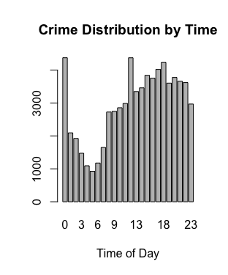

Code used:

Count the number of crimes per hour

```{r}

counts <- table(crimes$hour_occur)

counts

barplot(counts, main="Crime Distribution by Time", xlab="Time of Day")

```

**Linear Models:**

Code:

Run the linear model

```{r lm}

lm.count <- lm(X ~ hour_occur, data = crimes)

summary(lm.count)

```

The hour a crime occurs is statistically significant with p=2e-16. Adjusted R^2 = .0001268

Forward Selection:

```{r lm}

lm.count <- lm(X ~ hour_occur + month_occur, data = crimes)

summary(lm.count)

```

Hour statistically significant at p=.00191 and month statistically significant at p=2e-16. Adjusted R^2 = 0.01929

```{r lm}

lm.count <- lm(X ~ hour_occur + month_occur + year_occur, data = crimes)

summary(lm.count)

```

Hour statistically significant at p=.05 and month statistically significant at p=2e-16, year statistically significant at p=2e-16. Adjusted R^2 = 0.05559

```{r lm}

lm.count <- lm(X ~ hour_occur + month_occur + year_occur + year_rept, data = crimes)

summary(lm.count)

```

Hour statistically significant at p=.05 and month statistically significant at p=2e-16, year statistically significant at p=2e-16. Adjusted R^2 = 0.05559

Findings:

-linear model was basically useless provides us with tiny Adjusted R squared.. Is this even worth including?

-the largest adjusted R^2 is only ever around .06

-n>p

**Piecewise**